NDDS Reconciliation JOB AID
Description: | Reconciling the NDDS Client and Broker Deposits at RBC to T24
Target audience | Reconciliations Group
Prerequisites | RBC Express, T24, FileNet
Service Level Objective | Same Day
Date published | Nov 13, 2019

Policy statements

Trigger
Customer makes a NDDS Deposit at an RBC Branch.

Steps
Step | Instruction
1 | Login to T24 and pull the Client NDDS Details for today’s date.  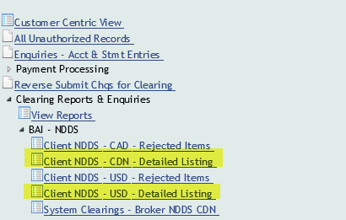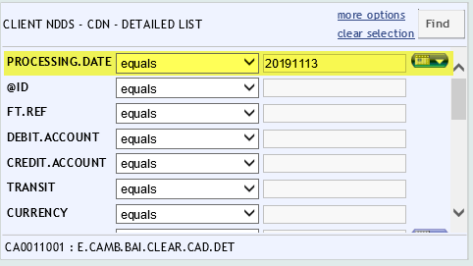
2 | Enter the totals on the last page into the rec and take a screenshot to attach to the backup on the rec.  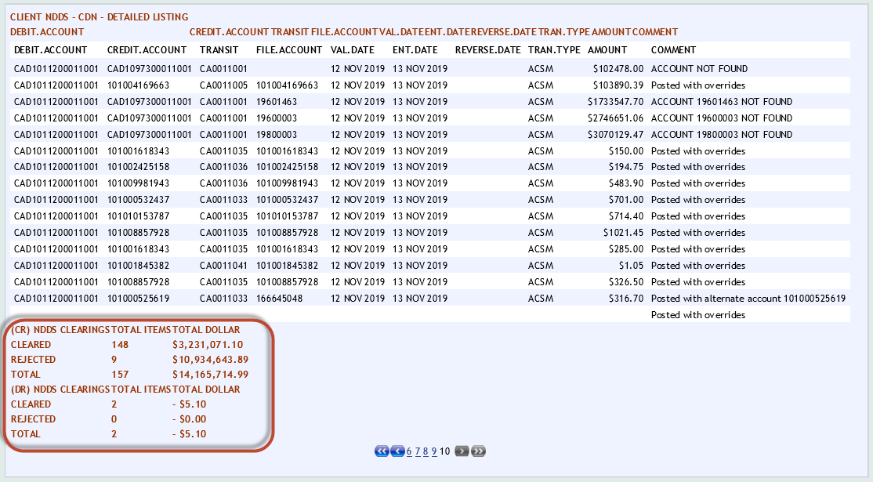  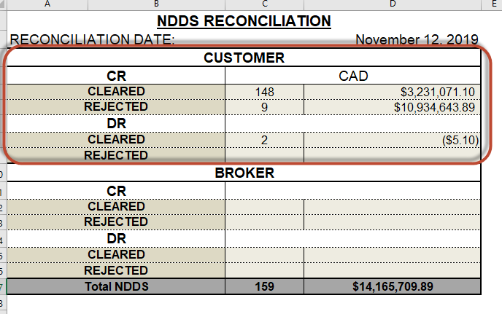  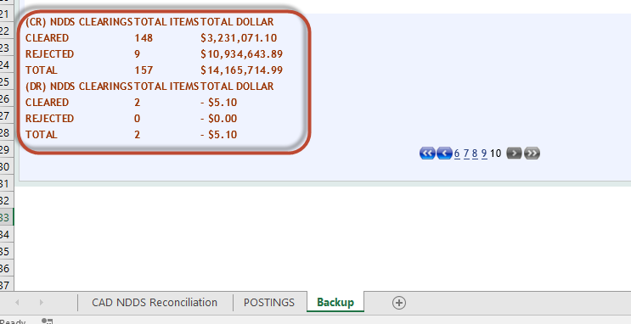
3 | For CAD, pull the Broker NDDS Details for today’s date. 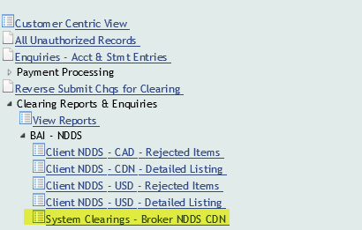 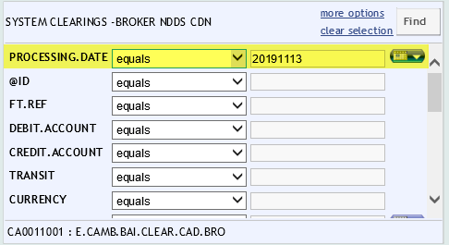
4 | Enter the totals on the last page into the rec and take a screenshot to attach to the backup on the rec. 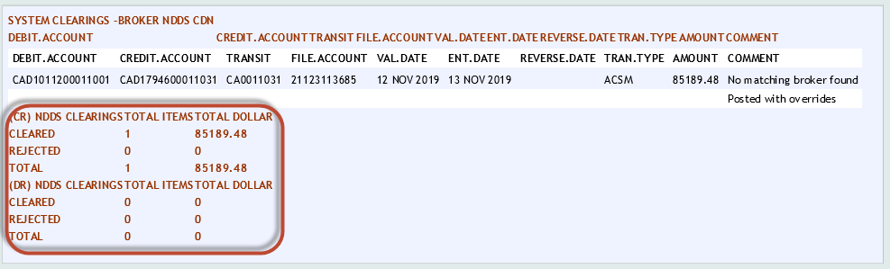  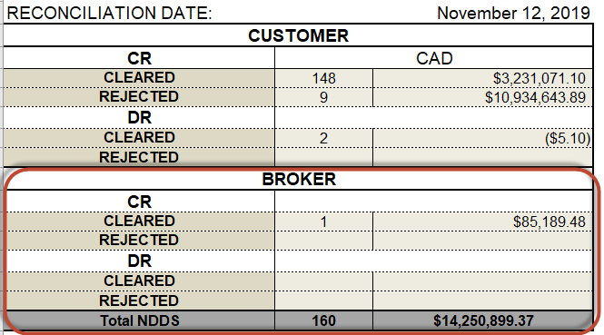  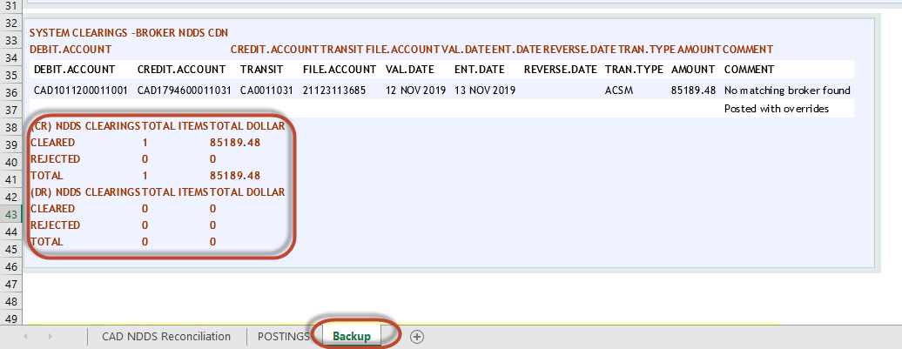
5 | Pull the closing balance of the NDDS Internal Account (CAD1011200011001 & USD1011200011001) as of today’s date.  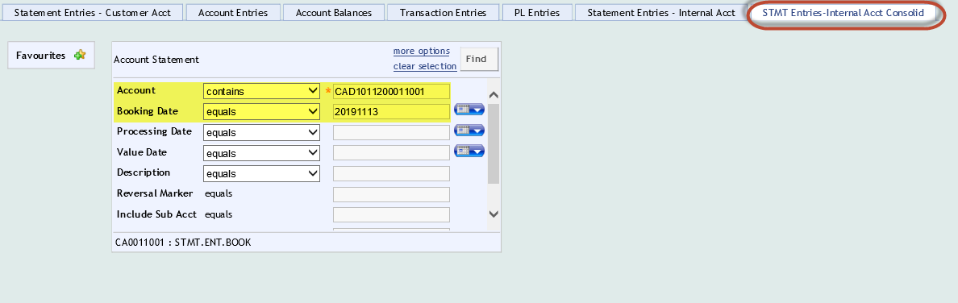
6 | Enter the balance into the rec and take a screenshot to attach to the backup on the rec. The difference should be at 0.  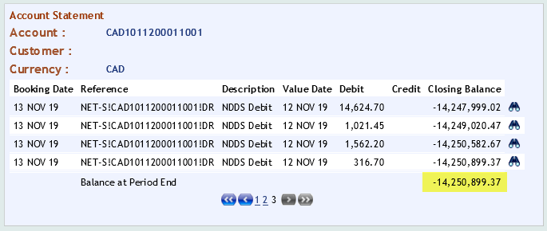  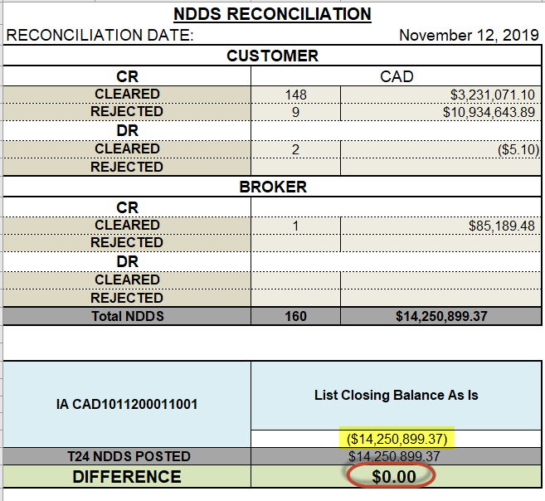
7 | Login to RBC Express and pull the NDDS Account statements as of the rec date, including backdated transactions (CAD accounts: 1013192 and 1013218; USD account: 4003968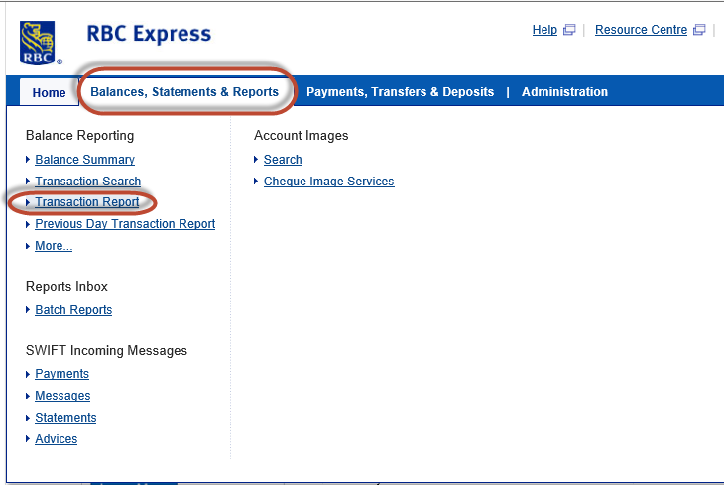  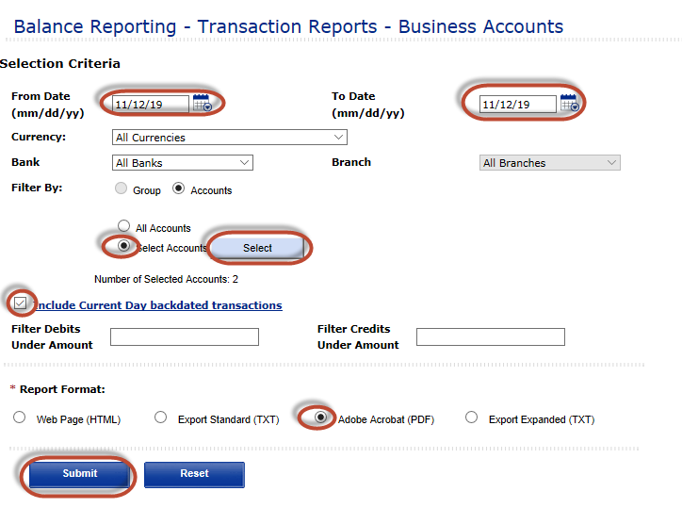  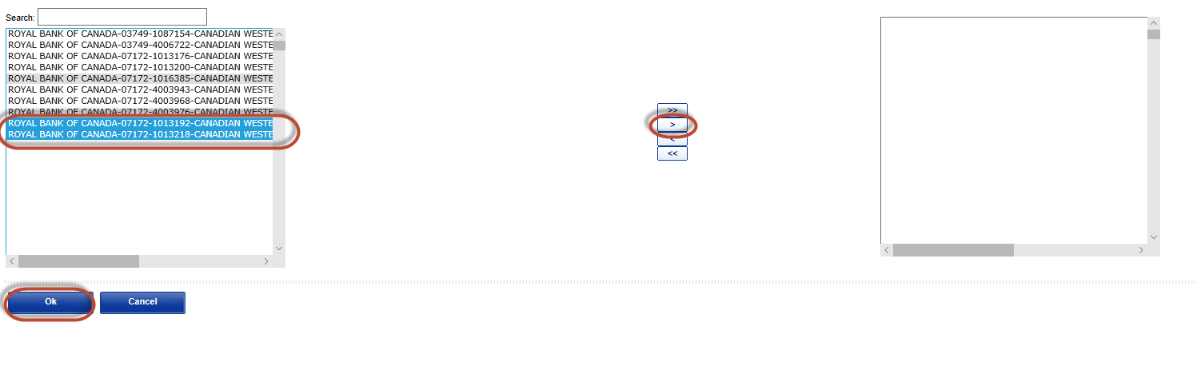
8 | Enter the balances into the rec and take a screenshot to attach to the backup on the rec. The difference should be at 0.  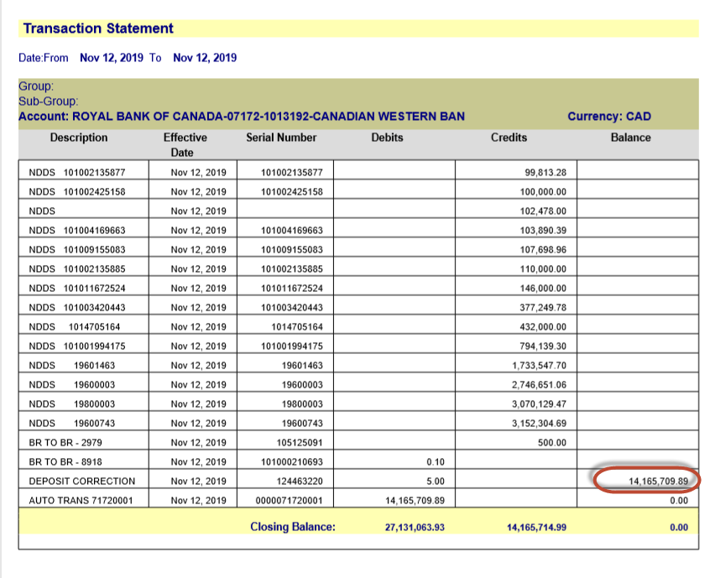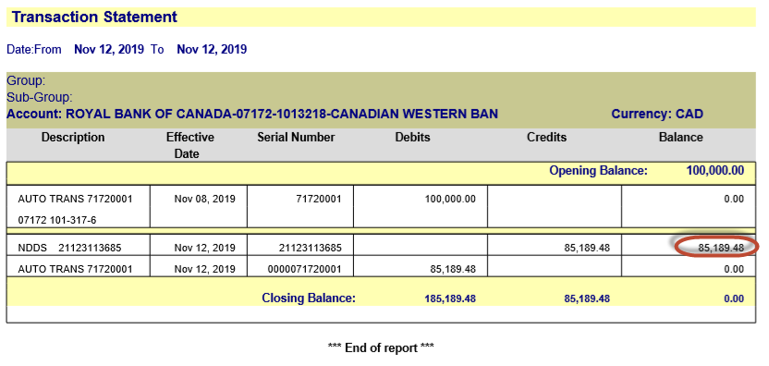  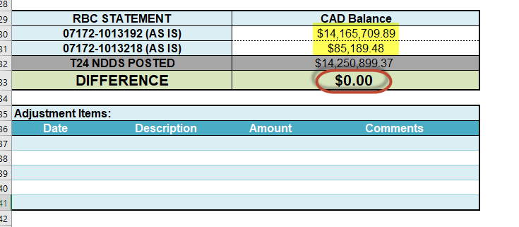
9 | Complete the postings on the postings worksheet.  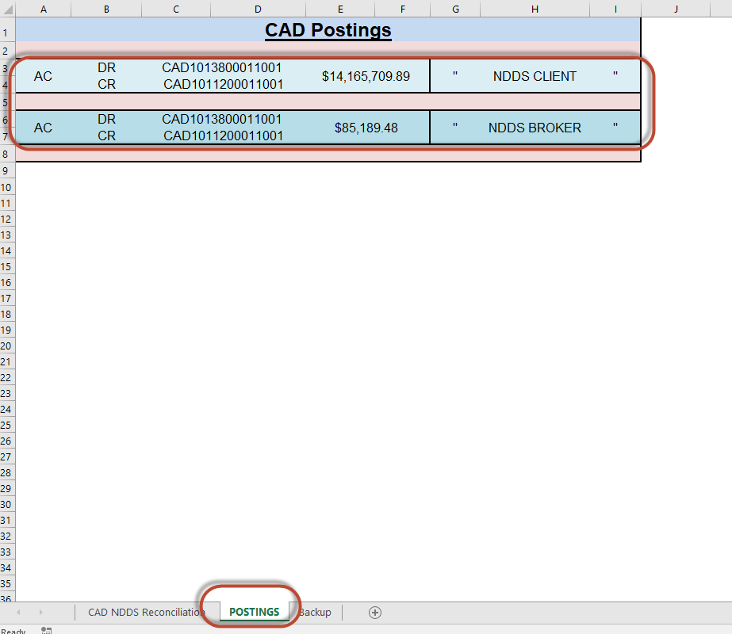
10 | Once both recs are complete, sign and upload to FileNet for checking.

Checklist

Troubleshooting

